Midtown Is Moving Forward To The Implementation Phase
December 1, 2022
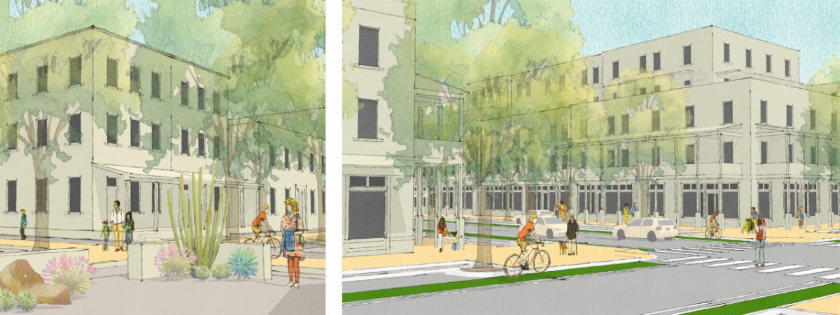
SANTA FE, December 1 – The Governing Body unanimously approved the Midtown Master Plan and rezoning application at last night’s meeting. Now, the City is moving forward with the next steps to take the revitalization of the site from planning to implementation. Three Request for Proposals (RFPs) will be released on Friday, December 2, to begin redeveloping and bringing people to the Midtown Site. These RFPs will begin transforming and activating the Midtown Site for future development.
The first three RFPs include:
- The Visual Arts Center
- Performing Arts Center
- Film Production Studio Expansion
"Last night’s vote is a huge and historic win for all of Santa Fe," said Mayor Alan Webber. "The whole city owes a debt of gratitude to City staff and community members who worked extremely hard, with great skill and enormous vision, to produce a world-class plan for a world-class site. As of tomorrow morning, when three RFPs go out, Midtown Santa Fe is open for business!”
“These early start development projects are the catalysts for the renaissance of the Midtown Site,” said Rich Brown, Community and Economic Development Department Director. “Our strategy is to identify early opportunities that leverage existing infrastructure and reuse of existing buildings to activate the site and initiate interest with the development community, while also ensuring these existing buildings are put back into public use that ground Midtown arts and culture – a vision we heard from so many people and organizations throughout the planning process.”
Starting tomorrow, the RFPS will be posted on the City’s website, including detailed descriptions and instructions on how to respond.
Download an overview of the Midtown Redevelopment Plans here. The City encourages all Santa Feans to keep abreast of the Midtown Moving Forward process on the project website: MidtownDistrictSantaFe.org

RFPs Overview:
Midtown Visual Arts Center
Visual Arts RFP seeks the redevelopment and operation of the existing Center into a dynamic and create a HUB with a mix of arts and technology uses. This HUB will be occupied with arts and cultural organizations that promote community creativity unique to Santa Fe and its communities, as well as technology uses that build on a vision of innovation, jobs, and design. The operations will be self-sustaining and consider a mixed model of affordable and market-rate lease spaces. In addition, the Selected Respondent will be responsible for public arts programming to begin activating and bringing the public to Midtown. The Selected Respondent is responsible for securing capital for the rehabilitation of the existing center, as well as operating costs with the capacity for securing private capital or charitable contributions to ensure sustainable operations. The Selected Respondent is responsible for financing, renovation, programming, tenant, and managing an arts, education, and cultural HUB within the existing Visual Arts Center buildings and adjacent outdoor spaces and courtyards at the Midtown Property.

Midtown Performing Arts Center
The Performing Arts RFP seeks the redevelopment and operation of the existing Greer Garson Theatre Center into a fully operating performing arts center. The facility is to be programmed and modeled on high-quality public theater programming best practices that attract and are accessible and affordable to community groups, as well as regional, national, and international companies. The operations will be self-sustaining that considers a mixed model of affordable and market rate use rates throughout the year. The Selected Respondent is responsible for securing private capital or charitable contributions for the rehabilitation of the existing center, as well as operating costs with the capacity for securing private capital or charitable contributions to ensure sustainable operations.

Midtown Production Studio Expansion
The Production Studio RFP seeks the redevelopment, expansion, and operation of the existing Garson Film Production Studios into a competitive, modern studio facility (including pre and post-production capacity) that attracts regional, national, and international productions to Santa Fe, and specifically the completed studios at Midtown. The proposed project should consider a training and career education component in collaboration with a quality higher education institution, such as the University of New Mexico and/or Santa Fe Community College Film & Digital Arts programs. In addition, the proposed project should consider movie programming in the existing screening room that provides interest and access for Santa Fe’s communities. The Selected Respondent will be asked to consider expansion on adjacent privately owned properties for complementary and supportive uses and/or expanded production facilities. The Selected Respondent will be responsible for securing private capital or charitable contributions for the rehabilitation of the existing center, as well as operating costs with the capacity for securing private capital or charitable contributions to ensure sustainable operations.

